1. **Introduction**
   1. Arrangement of collections of data items so that they can be utilized efficiently, operations on that data can be done efficiently.
   2. Type of data structure
      1. Physical : Arrays, Linked List
      2. Logical: Stack, Queue, Tree, Graph and Hash Table
   3. Linear & Non-Linear DS
      1. Linear : Arrays, Linked List, Stack, Queue
      2. Non-Linear: Tree, Graph
      3. Tabular/ Linear: Hash Table
   4. Abstract data type
      1. Representation of data
         1. Array or linked list or stack or tree
      2. Operation on data
         1. Add, remove, search, sort
   5. Time and Space Complexity
2. **Array**
   1. Introduction
      1. What is an Array
         1. An array is a linear data structure that stores similar elements that are stored in contiguous memory locations.
      2. Declaring and Initializing

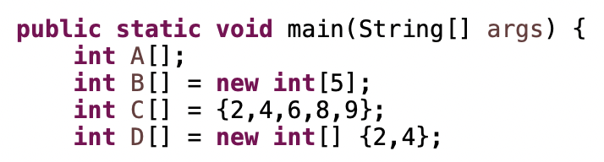

* + 1. Accessing Array

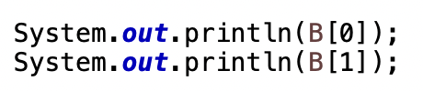

* 1. Array ADT
     1. Representation of data

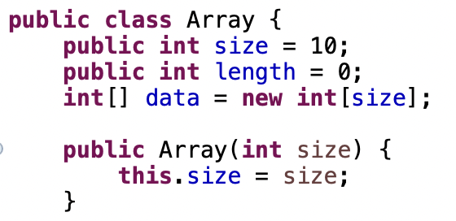

* + 1. Operations on data
       1. Insertion

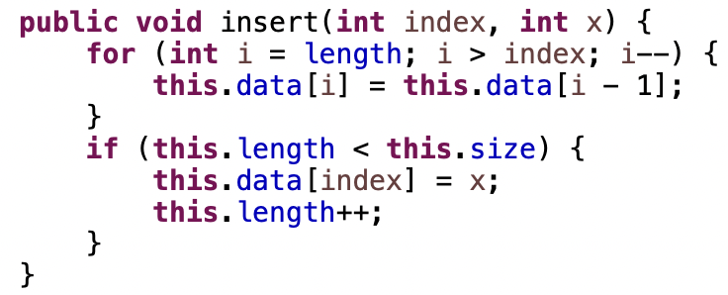

* + - 1. Append

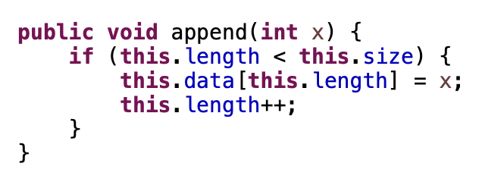

* + - 1. Remove

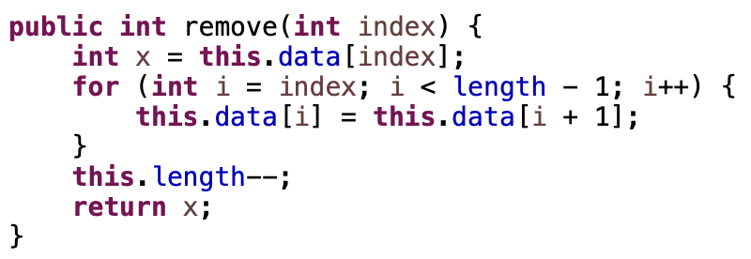

* + - 1. Get

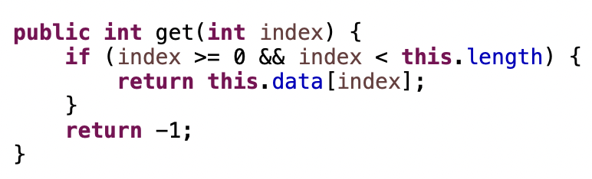

* + - 1. Set

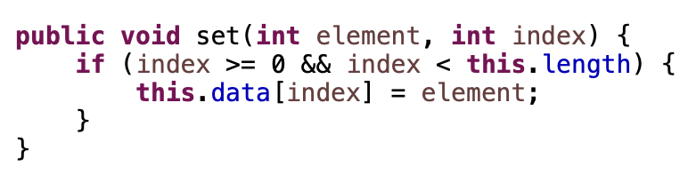

* + - 1. Max element

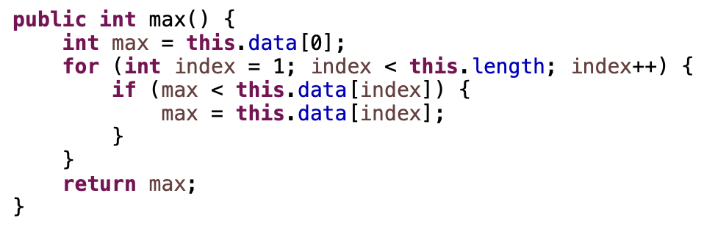

* + - 1. Print All elements

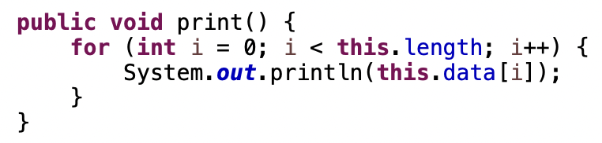

1. **Recursion**
   1. What is recursion
      1. A function call itself is called recursion
      2. There are two phase in recursion:
         1. Calling phase: do something before calling itself
         2. Returning phase: do something after calling itself

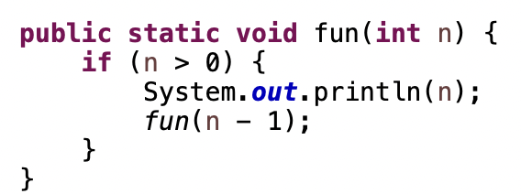

* 1. Type of recursion:
     1. Tail Recursion: last statement is recursion call (In case of tail recursion for or while looping is more efficient)



* + 1. Head Recursion: first statement is recursion call

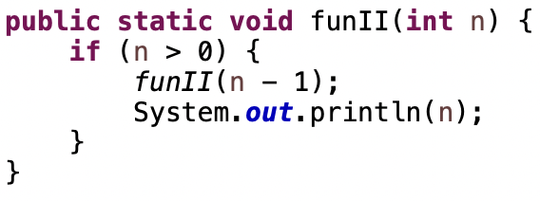

* + 1. Linear Recursion: recursion call at middle. (1 call only)

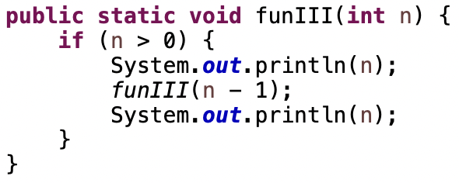

* + 1. Tree Recursion: more than 1 recursion calls

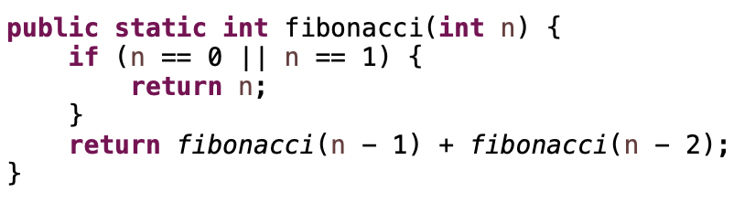

* + 1. Indirect Recursion: 1st function call 2nd and 2nd function call 1st.
    2. Nested Recursion: recursive call pass as parameter to the function

1. **String**
   1. Introduction
      1. String can be represent as array of character

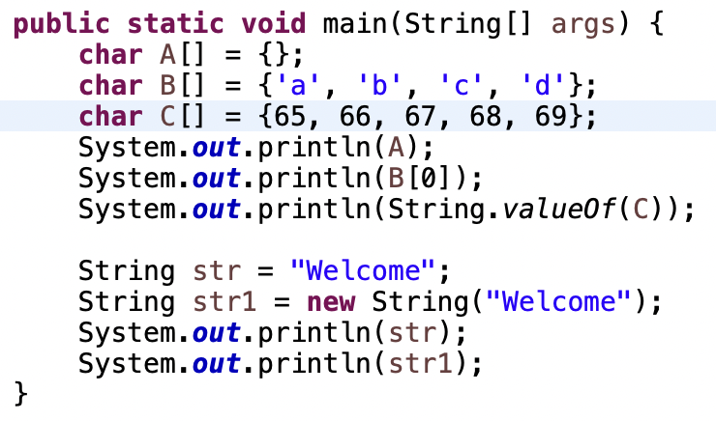

* + 1. ASCII Codes/Values
       1. Total no chars are 128 (0 to 127), 1 Bytes == 7 bits so 2^7 = 128 (0 to 127)
       2. No of character in both lower and upper is 26
       3. Lower Case Range: 97 to 122
       4. Upper Case Range: 65 to 90
       5. Lower case and upper-case difference is 32.

1. **Matrix**
   1. Array in 2D form
   2. Diagonal Matrix
      1. M[i][j] = 0, if all i != j
   3. Lower Triangular Matrix
      1. M[i, j] = 0, if i < j
      2. M[I, j] != non-zero, if i >= j
      3. No of non-zero = n * (n + 1) / 2
      4. No of zero = n * (n - 1) / 2
      5. Row Major Mapping
         1. Index(A[i][j]) = [i * (i - 1)] / 2 + (j - 1)
      6. Column Major Mapping
         1. Index(A[i][j]) = [n(j - 1) – (j - 2)(j - 1) / 2] + (i - j)
   4. Upper Triangular Matrix
      1. M[I, j] = 0, if i > j
      2. M[I, j] = non-zero, if i > j
      3. No of non-zero = n * (n + 1) / 2
      4. No of zero = n * (n - 1) / 2
      5. Row Major Mapping
         1. Index([i][j) = [(i - 1)n – (i - 2)(i - 1)] + (j - 1)
      6. Upper Major Mapping
         1. Index([i][j]) = [j * (j - 1) / 2] + (i - 1)
   5. Symmetric Matrix
      1. M[i, j] = M[j, i]
   6. Tri-Diagonal
      1. M[i, j] = non-zero, if abs(i - j) <= 1
      2. M[I, j] = 0, if abs(i - j) > 1
      3. No of non-zero = 3n – 2
      4. Index(M[i][j])
         1. If i – j = 1, index = i – 1
         2. If i – j = 0, index = n – 1 + i – 1
         3. If I – j = -1, index = 2n – 1
   7. Toeplitz Matrix
      1. M[i, j] = M[i – 1, j – 1]
      2. Index(M[i, j])
         1. If i <= j, index = j – i
         2. If i > j, index = n + i – j – 1
   8. Sparse Matrix Representation
2. **Searching** 
   1. Linear Searching
      1. Time complexity: O(n)

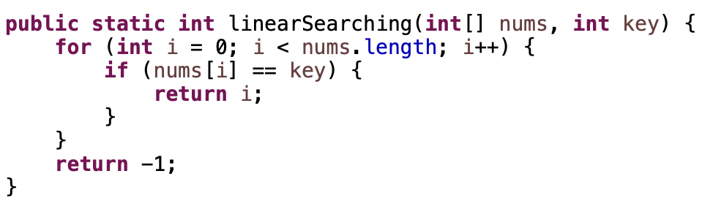

* 1. Binary Searching
     1. It is a searching algorithm used in a sorted array by repeatedly dividing the search interval in half.
     2. Time complexity: O(log n)

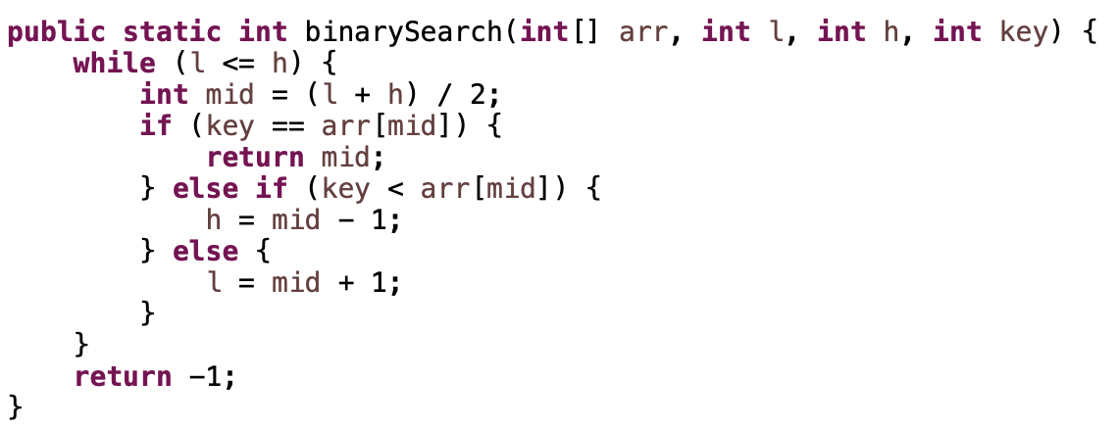

1. **Sorting**
   1. Bubble Sort

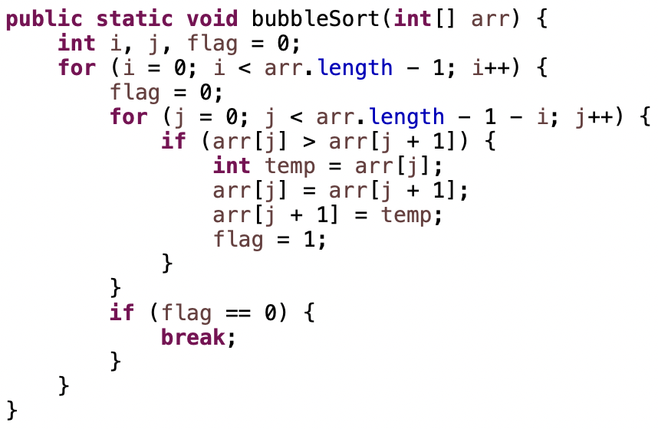

* 1. Selection Sort

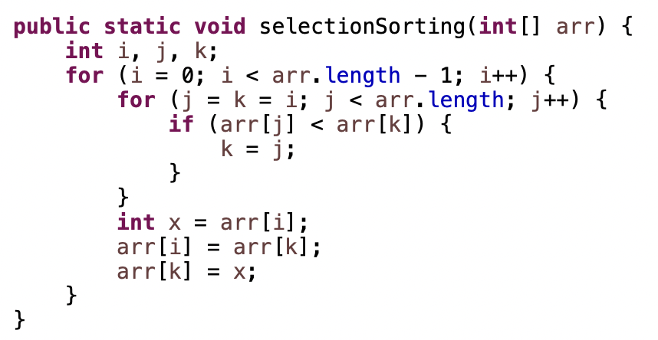

* 1. Insertion Sort

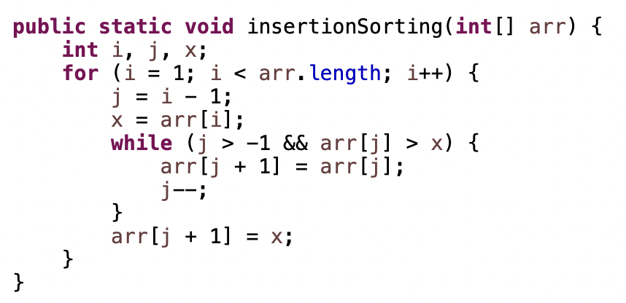

* 1. Quick Sort (Divide and Conquer)

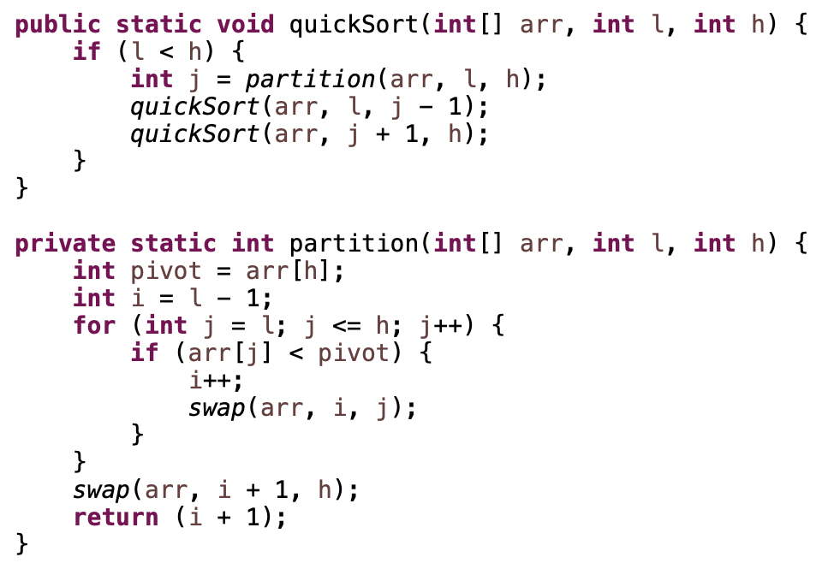

* 1. Merge Sort (Divide and Conquer)

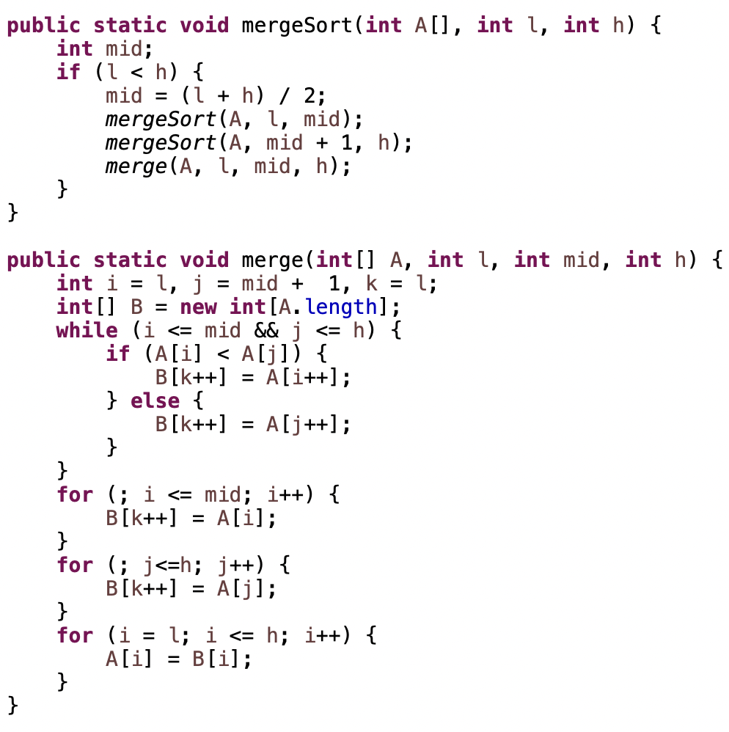

* 1. Counting sort

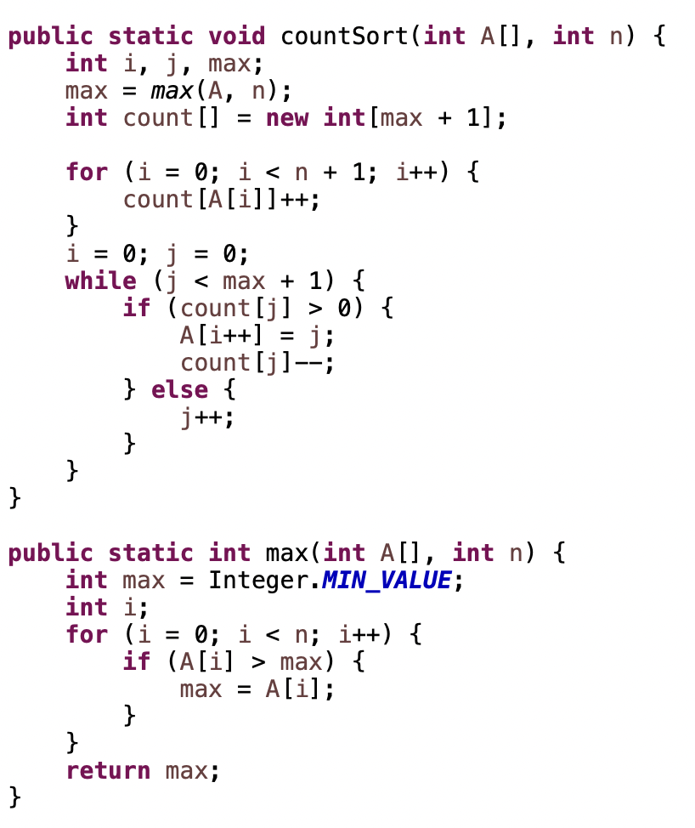

* 1. Bins Sort (Linked List)

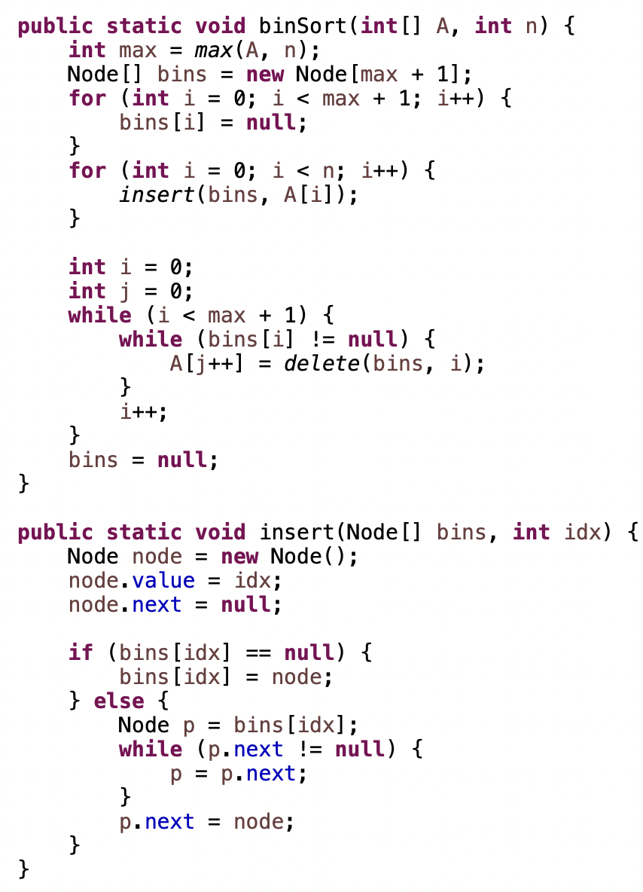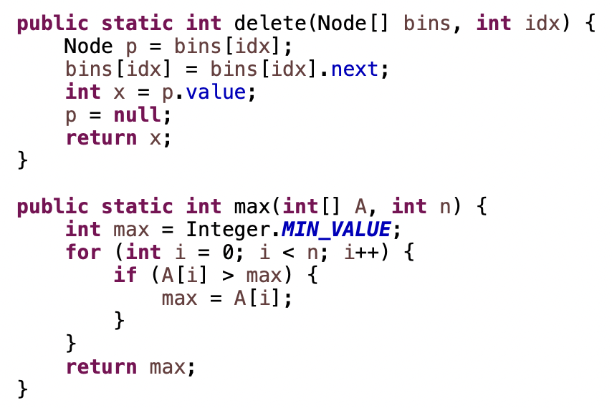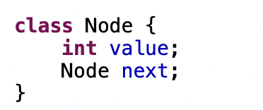

* 1. Radix Sort (LinkedList)

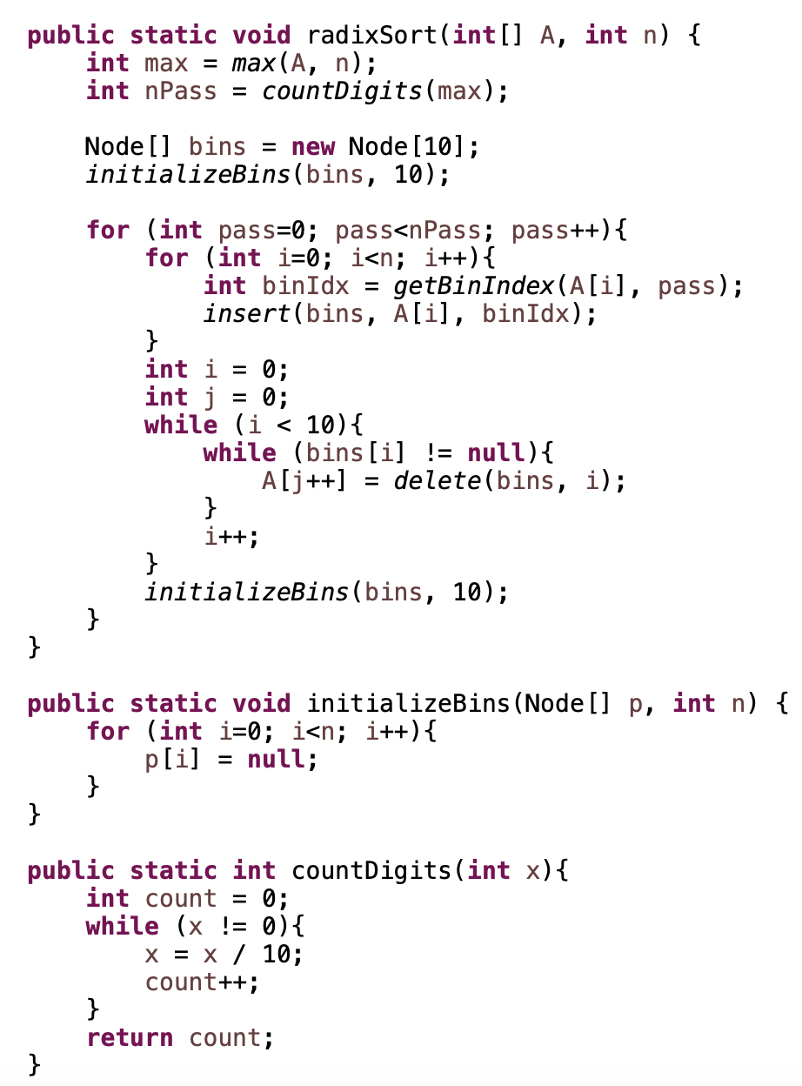

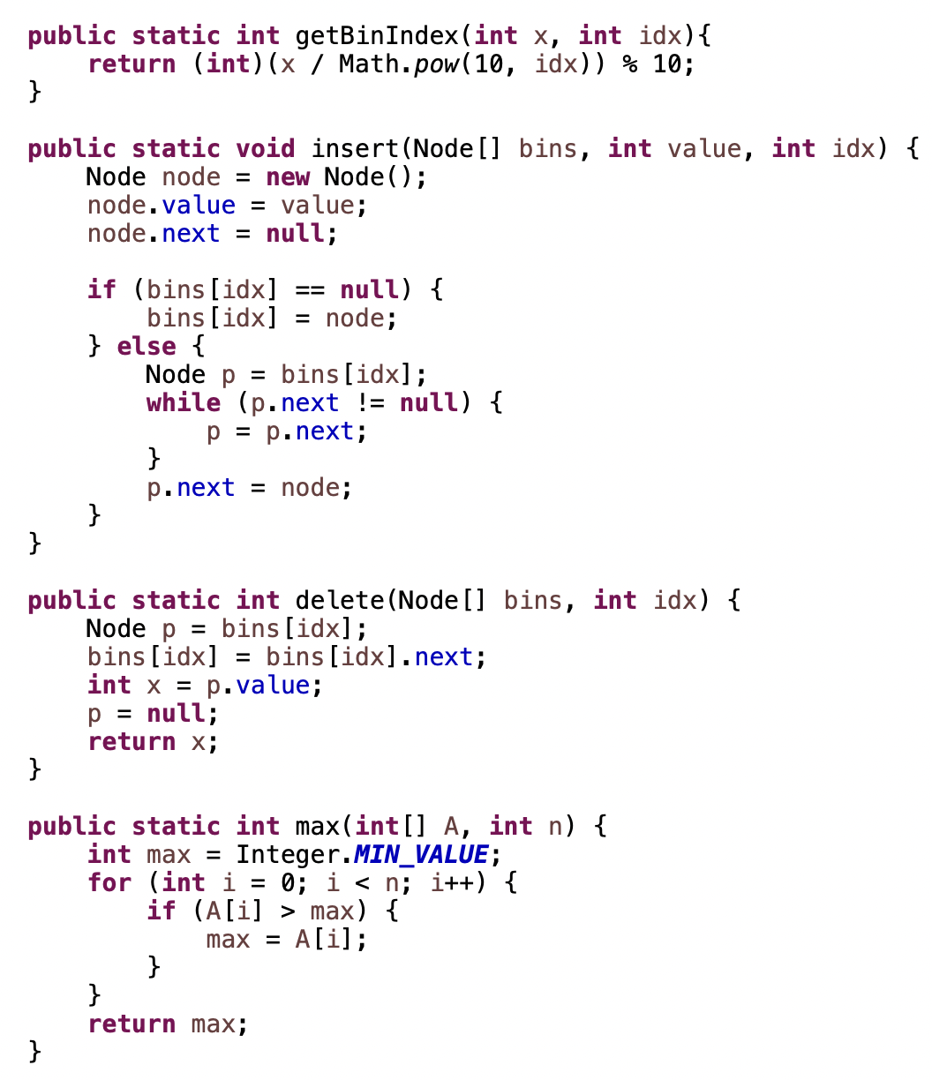

1. Bitwise
   1. AND (&), OR (|), XOR (^), NOT(~), Left Shift(<<), Right Shift(>>)

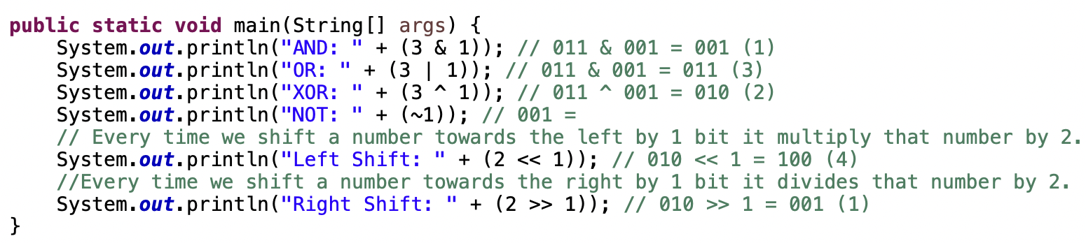

* 1. Difference between binary and decimal number

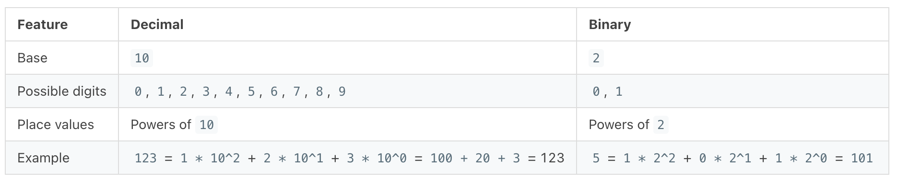

* 1. Find next bit

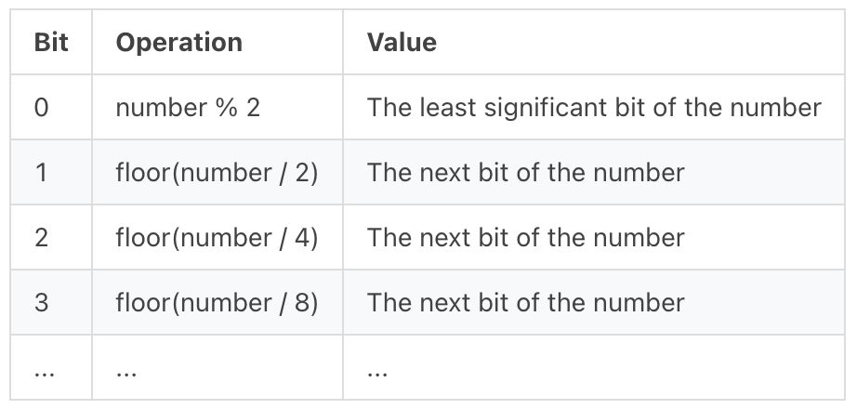

* 1. Important Points of Bitwise algorithms
     1. How to set a bit in the number

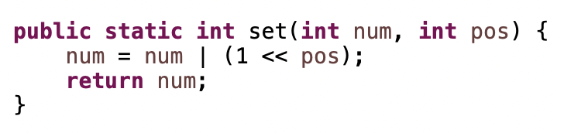

* + 1. How to unset/clear a bit at nth position in the number

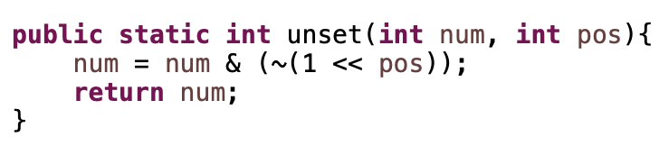

* + 1. Toggling a bit at nth position

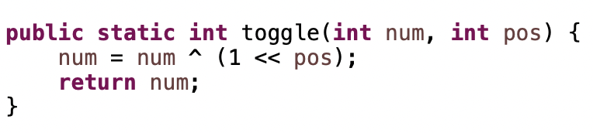

* + 1. Checking if the bit at nth position is set or unset

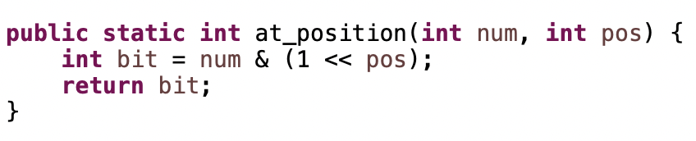

* + 1. Multiply a number by 2 using the left shift operator

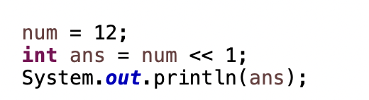

* + 1. Divide a number 2 using right shift operator

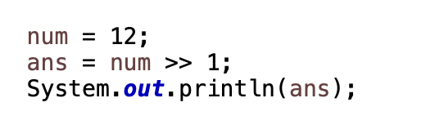

* + 1. Compute XOR from 1 to n (direct method)

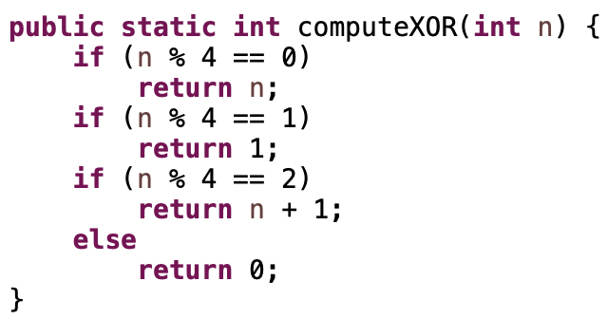

* + 1. How to know if a number is a power of 2

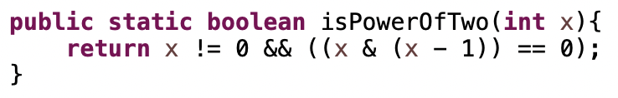

* + 1. Count set bits in a number

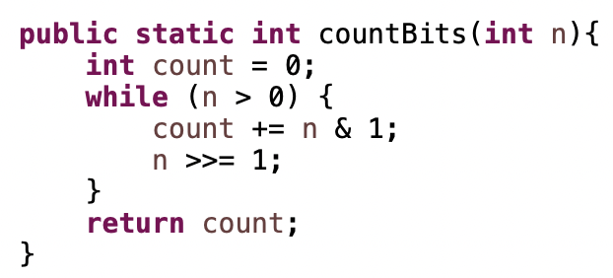

* + 1. Position of right most set bit

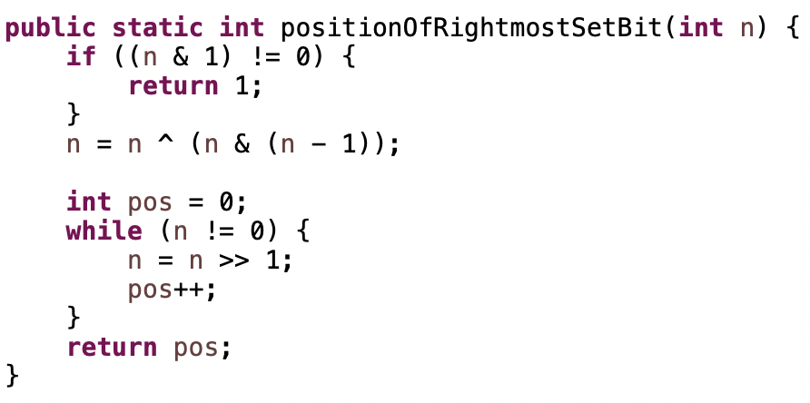

* + 1. Swap two number

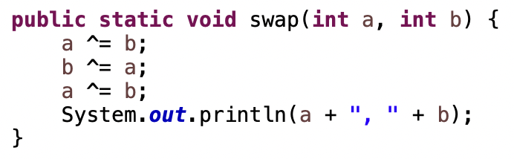

* + 1. Print all bit

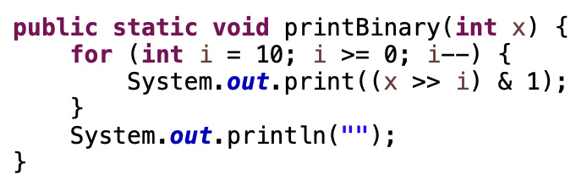

* 1. Character Bitwise
     1. Difference between upper case letter and lower-case binary is that
        1. In upper case letter 5th bit != 1
        2. In lower case letter 5th bit = 1
     2. Convert char to lower case and upper case

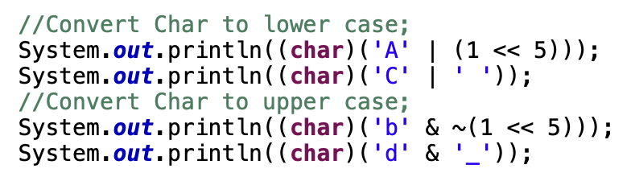

* + 1. Find a letter’s position in alphabet

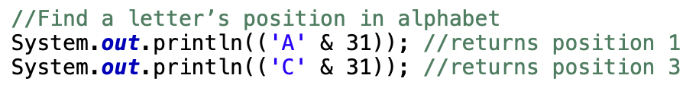

* 1. Complement and Two Complement
     1. Complement

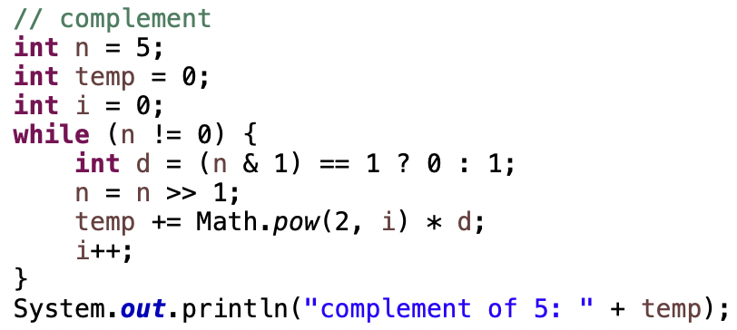

* + 1. Two’s Complement
       1. In two’s complement, the MSB is a sign bit.
       2. A 0 in the MSB indicates a positive number while a 1 indicates a negative number
       3. The remaining 31 bits are used to represent the magnitude of the number.
       4. Negative Number = ~ Positive Number + 1
       5. In 2’s complement representation, subtraction can be done by simply adding the two numbers together
       6. Difference = num1 + (~num2 + 1)

1. Linked List
   1. Linked ADT
      1. Representation of data

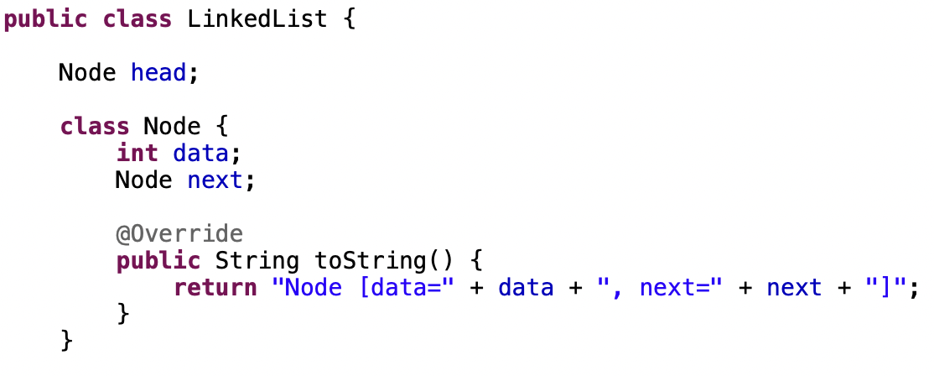

* + 1. Operation on data
       1. Add First

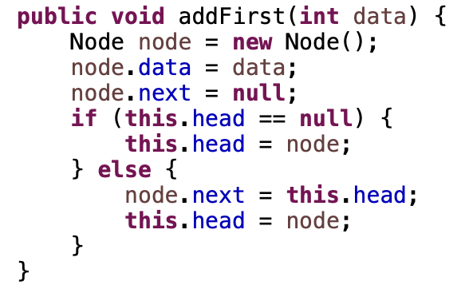

* + - 1. Add Last

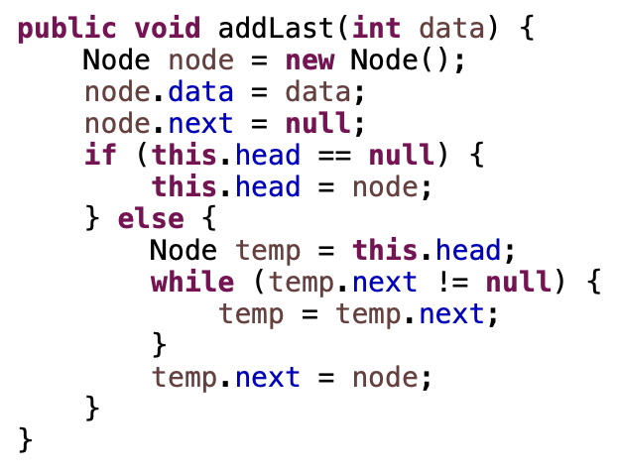

* + - 1. Remove First

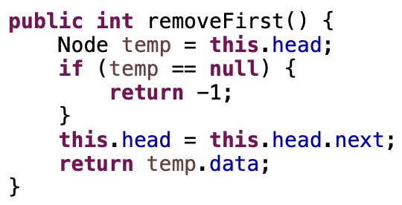

* + - 1. Remove Last

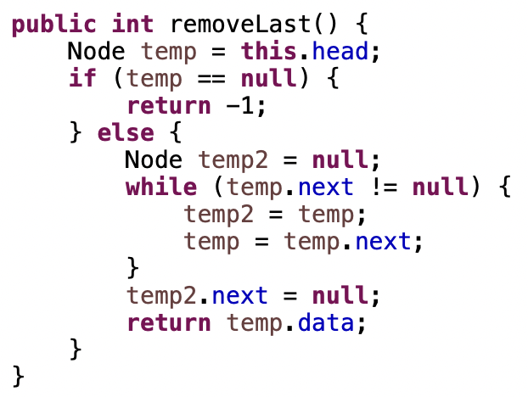

* + - 1. Count Number of Nodes

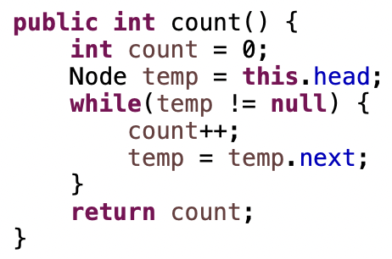

* + - 1. Search

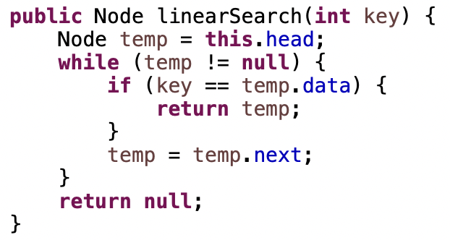

* + - 1. Reverse LL

